# Detailed Project Proposal

|  |  |
| --- | --- |
| First Name: | Andrew |
| Last Name: | Trail |
| Student Number: | 1203154 |
| Supervisor: | Kit-ying Hui |

## Defining your Project

**1.1 Project title**

**Help:** a brief statement about what you are actually going to do.

|  |
| --- |
| Drone Delivery Scheduler |

**1.2 Background**

**Help:** Provide the background to your project. This section should highlight the main topics in the area you are going to research. Essentially what is the project about, what has been done before and why is this project important? ~500 words

|  |
| --- |
| The aim of this project is to create an automated drone delivery scheduler. It will simulate delivery of objects via drones to customers in so called ‘last mile’ deliveries. The solution should find the optimal pattern of delivery based on a number of variables, such as wind speed/direction, ‘no fly zones’ and the weight of the object being carried.  There are several companies who are known to be working on a similar service, notable Amazons ‘Prime Air’, googles ‘Project Wing’ and FedEx. None of these companies have fully released a service to consumers yet, but Amazon is expected to roll out their service in the late months of 2019 for selected cities. It is currently doing a trial in Cambridge for select customers.  There is limited information surrounding these projects, however it is safe to assume they are using AI to schedule deliveries and calculate flight paths. I will be creating a similar solution.  The project is important as I believe it is the future of delivery services. Besides the companies mentioned above, there are many more who are working on delivery services using drones, with applications ranging from food delivery, to emergency supplies on the front line of a war.  The use of drones will only increase, and it is vital for companies using them for delivery to be able to have a reliable and optimal delivery scheduler. This saves money for the company which is an important factor for them. The customer is also happier when their parcel is delivered quicker than possible using a traditional van method.  I will be exploring the use of AI for this task, however it may not be feasible with current information available for me to research and adapt to this purpose. |

**1.3 Motivation**

**Help:** To whom is this project important? A project must address a question/problem that generates a small piece of new knowledge/solution. This new knowledge/solution must be important to a named group or to a specific client (such as a company, an academic audience, policy makers, people with disabilities) to make it worthwhile carrying out. This is the ***motivation*** for your project. In this section you should address who will benefit from your findings and how they will benefit. ~300 words

**Example** 1: If you intend to demonstrate that a mobile application that automates class registers at RGU will be more efficient than paper-based registers - the group who would be interested in knowing/applying these findings would be both academic and administrative staff at RGU and they would benefit by time saved and a reduction in their administrative workload.

**Example** 2: You are demonstrating that a particular 3D model design increases realism in 3D environments. The group that would be interested would be games designers or developers of 3D virtual environment applications. The would benefit from producing more realistic environments that could increase sales of their products.

**Example** 3: You have designed a new network topology for IrishOil plc’s new Aberdeen headquarters. The interested group would clearly be IrishOil. They would benefit from easier maintenance and improved security of their computer network.

|  |
| --- |
| There is no specific company that would benefit from my findings, as I am not working with a specific company. However, if I find that the project is viable, and produce a solution that works well, this could be used by any company to implement drone delivery for themselves. This has implications of saving the company money, as they wouldn’t have to employ delivery drivers to drive a van or pay a third party to do this for them. Additionally, it will help to prevent issues such as drones running out of battery mid-flight, and to improve delivery times, and give customers a more accurate estimated delivery time.  It also has implications for individuals and small companies. For example, a single person who sells homemade products like jewellery on ebay or etsy could benefit from purchasing a handful of drones and using the system for themselves to deliver to the area surrounding their home. |

**1.4 Aim & Objectives**

**Help:** Outline what are the main things your project is going to do and what steps or milestones will be used to achieve this aim. The Aim is unlikely to change throughout your project; however, the objectives are likely to adapt to your ongoing research and development. In particular it is highly likely that you may wish to split objectives into sub-objectives as work progresses. A good clear set of objectives give you something to evaluate your final project against.

**Example** : For the timetable app outlined above

Aim: To create a functioning attendance application that efficiently automates the taking of class registers.

Objective 1: study existing register system in place at RGU and identify weaknesses

Objective 2: research existing automation technology’s and identify and evaluate those that may be appropriate to taking in class registers

Objective 3: Implement chosen technologies to create prototype application

Objective 4: Conduct user trials to evaluate capabilities of prototype application

Objective 5: Create a refined application incorporating feedback from user trials

|  |
| --- |
| Aim: To create a drone delivery scheduler  Objective 1: Study existing implementations of delivery scheduling and see if they can be adapted and applied to drones.  Objective 2: Study limitations of drones that are currently available.  Objective 3: Research sources of data for the variables used to simulate the problem. Weather data, areas drones cannot fly etc.  Objective 4: Select the best sources of data and method of solving the problem, implement a solution.  Objective 5: Test the system extensively to find any faults.  Objective 6: Implement any findings from the testing and test the new optimised solution.  Objective 7: Evaluate the final solution and draw a conclusion about its fitness for purpose. |

**1.5 Key Techniques**

**Help:** Perform some initial research into the area and outline what techniques you my research in further detail here. The techniques you cover here should include references to the papers where you have sourced the information. The techniques mentioned here are very likely to become the section headers in your literature review.

|  |
| --- |
| A* Travelling Salesperson. In this case, the drone can carry multiple packages and make multiple deliveries in one trip. This problem can be solved with an A* search and a strong heuristic. The solution must find the shortest path for a drone to take. (Siregar et al ., 2017 https://iopscience.iop.org/article/10.1088/1742-6596/801/1/012038/pdf.)  Grouping delivery locations. I must research how to group delivery locations into groups that can then have a path determined and a drone assigned.  Simulated Annealing may be a useful technique. If there are a large quantity of packages to be delivered, the time taken to calculate the optimal route may take too long. If the system takes too long to find a perfect solution, it may end up taking more time to do this and perform deliveries then it could otherwise take with a sub optimal route. Simulated annealing can be used as a heuristic to help solve this issue. (Dorling et al., 2017 <https://ieeexplore.ieee.org/abstract/document/7513397>)  Vehicle Routing Problem – A problem that aims to find the optimal route for vehicles to use to deliver packages to customers. |

**1.6 Legal, Social, Ethical, Professional and Security issues**

**Help:** Here you should discuss any legal, social, profession and security issues that you believe may occur during the course of your project. It is not acceptable to write none in this box, all projects, regardless of focus will have to address issues in one, or more, of these categories. This is an extremely important part of your honours project to which there is no correct answer, this section must be fully discussed with your Honours Supervisor.

**Example 1** : In the class register example above – there would be a Legal and Security issue with the gathering and storage of student data. There may be a social constraint as you may be relying on a user to have access to a specific technology. There will need to be consideration of user accessibility.

**Example 2** : A 3D model design may have ethical considerations in its evaluation. What if your model made users feel nauseous. Social constrains may again be access to technology or accessibility issues.

**Example 3** : You network design need to adhere to specific company policies. You would need to consider the possibility that your design could be wrong, compromising the company’s security.

|  |
| --- |
| Legal:  Flying an unmanned drone, controlled by a piece of software is going to bring a host of legal issues. Who is responsible for the drone if it were to crash, the person who owns it, or the person who wrote the software? Additionally, how can it be certain that the drone is not going to fly through any restricted air space?  Social:  The proposed system may cause the loss of jobs. Last-mile delivery drivers who go from a depot in a city to peoples homes may become unemployed as a result of the service. Also noise of drones flying past and over peoples homes, and danger of the drone crashing into someone are all issues to take into account.  Security:  An initial security issue is that of hacking. If someone managed to gain control over the system, they could alter the way the drones function, causing them to steal packages by delivering them to a specified location, or cause injuries to people by crashing into them, onto roads for example.  Also the possibility of people managing to take drones out of the sky and steal what they are carrying. This also falls under a professional issue, as a company who’s products are routinely stolen will not be received well by the public. |

**1.7 Project Plan**

**Help:** This is the project plan as to how you will go about achieving the objectives of the project.

**Example**: In the class register example above the research plan may involve:

Collecting and analysing paper-based registers in a given class on five occasions.

Identifying the error rate average on these occasions

Researching existing automation techniques

Designing and implementing a mobile application that automatically records attendance in class.

Deploying the application in the class on five occasions.

Identifying the error rate average of the mobile application on these occasions.

Comparison of data and summary of findings.

|  |
| --- |
| Research current implementations of drone delivery systems. Analyse how they have been implemented, if AI has been used.  Research drones that are currently on the market. How far can they fly, what weight can they carry, how much do they cost?  Research weather data APIs and laws surrounding drone flight specifically unmanned.  Select the best of the above findings and conduct further research to see if they are viable methods to solve the problem  Begin implementing a prototype  Optimise the solution based on findings from testing  Evaluate the solution vs the aim and objectives  Begin combining everything into a final report |

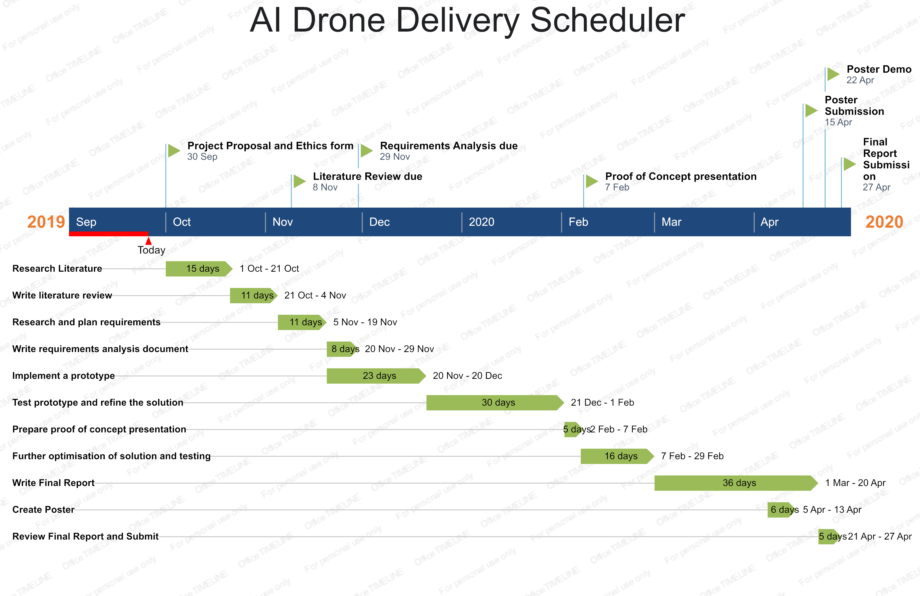

**1.8 Ethics Form**

**You must include in your signed ethics form in this submission or you will not be able to continue the project.**